**DESCRIPTION OF THE PROJECT CODING AND IMPLEMENTATION**

**Project Deisgn and Coding**

Model Training Flowchart Design:

Model Training Flowchart Pseudocode:

1.0 Start

1.1 Input FaceImage

1.2 Statistical Facial Extraction

2.1 Input Fingerprint

2.2 Give Class

3.1 Classified face and fingerprint

3.0 Stop

Full System Flowchart Design:

Full System Flowchart Pseudocode:

1.0 Start

1.1 Input FaceImage

2.1 If (statistical extraction > 3)

2.1.1 LabelFace = 1

2.2 Else

2.2.1 LabelFace = 0

2.3 End

3.1 Input Fingerprint

4.1 If (correlation > 0.7)

4.1.1 LabelFingerprint = 1

4.2 Else

4.2.1 LabelFingerprint = 0

4.3 End

5.1 If (LabelFace = 1 && LabelFingerprint = 1)

5.1.1 System("Unlocked")

5.2 Else if (LabelFace != 1)

5.2.1 System("Face Not Detected")

5.3 Else if (LabelFingerprint != 1)

5.3.1 System("Fingerprint Not Detected")

5.4 Else

5.4.1 System("You are not registered")

5.5 End

6.0 End

MatLab Tools Used:

The tool “Guide” is used to create GUI for the software. Meanwhile, other recognition is using image recognition correlation, statistic and feature extraction model.

(GUI using tool MatLab GUIDE)

After created the GUI for the Smart Lock then researchers proceed with creating the training model to do facial recognition using statistic and feature extraction model

(Model Training)

Image above shown the Model Training where the coding will start by asking the user to enter an image to be train. Then the program will ask a class where to put the image. However, by giving the class won’t be enough, the model will do feature statistic extraction to calculate the statistical feature of image. Then is will reshape the model to 3x2 matrice and then 1x6 matrice to makesure the statistical feature is unique. If there are existing database, then it will load the databae and save it into the current database. If not it will create new database.

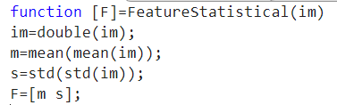

(Feature Statistical Calculation)

Image above shown the Feature Statistical Calculation of image. The calculation start with changing the image matrices into data type double. Then calculate the mean of mean of image and save it into variable “m”, and standard deviation of standard deviation of image and save it into variable “s”. Then return both m and s value.

(button 1)

Button 1 will upload the training image selected by user with file extension .png that will be store to first_face and first_face2gray global variable that can be access anywhere in the coding. Then save it into two different type first is regular image that will be display to axes1, then gray image that will be use for calculation and recognition

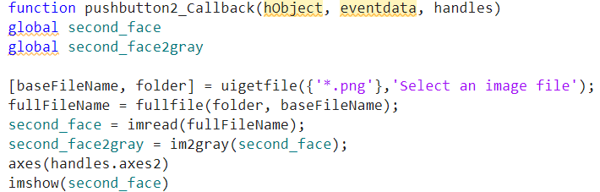

(button 2)

Button 2 will upload the testing image selected by user with file extension .png that will be store to second_face and second_face2gray global variable that can be access anywhere in the coding. Then save it into two different type first is regular image that will be display to axes2, then gray image that will be use for calculation, recognition and comparison to training image.

Button 3 will select an image of first or owner fingerprint that is file extension .png that will be store to first_fingerprint global variable that can be access anywhere in the coding, then the image will be converted to gray image. Image will be shown to the axes3.

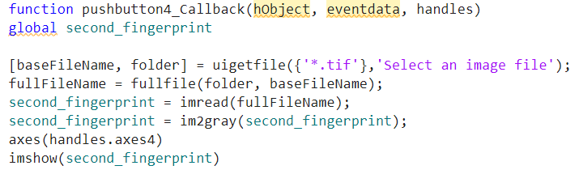

Button 4 will select an image of testing fingerprint that is file extension .png that will be store to second_fingerprint global variable that can be access anywhere in the coding, then the image will be converted to gray image. Image will be shown to the axes4.

(Button 5)

Button 5 is a recognition button where it will call all of the image stored variable. All gray variable is not used by developer due to flexibility of the model to calculate and recognize the image features. The function “corr2” will calculate the correlation between owner or first fingerprint and the second or testing fingerprint. Model testing will be call and the testing or second_face image stored variable will be used as the parameter where it will run through the test model. It will return the label whether 1 (recognized) or 0 (not recognized). If both face is recognized in database and fingerprint is same, then lock will be unlocked. Any other condition won’t unlocked the door, but it will display what is the problem encountered.

**Project Result:**

**Result : Both Facial and Fingerprint Recognized.**

**Result : Both Facial and Fingerprint NOT Recognized.**

**Result : Facial recognized but fingerprint NOT recognized**

**Result : Facial NOT Recognized but fingerprint recognized.**

